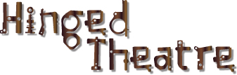
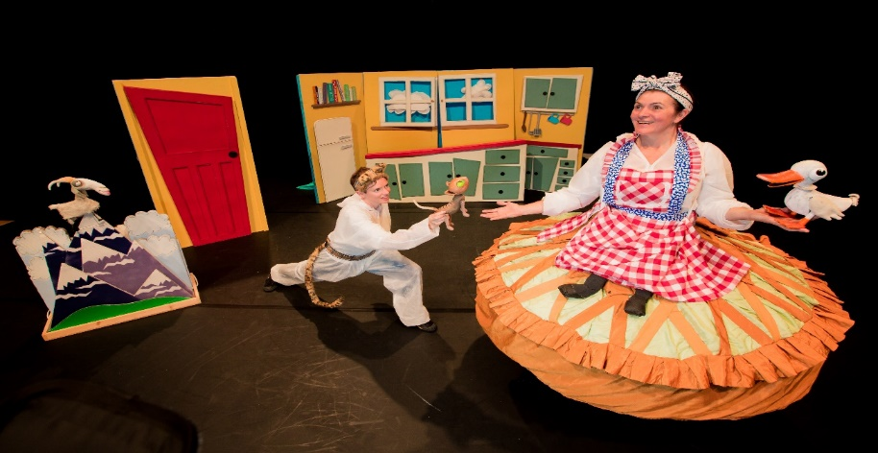
‘Sky in the Pie’
Technical Information

Generally
- Show running time—approx. 60 mins (dependent on audience participation)
- For a family audience age 3+
- Get in and fit up approx. 3-4 hours, get out approx. 1-2 hours
- Music specially designed and written for the show.
- Minimum space required 8m wide 7m depth and 3m high (there is some flexibility within this, please discuss if this is an issue)
- Requires one or two very light rigging points to suspend the flying pie with puppets and the cardboard baddies. All pulleys and line etc. supplied by the company. Access to the lighting points above stage required from ladder or tallascope. Alternatively these can be pre-rigged. (Short discussion with the venues individual technician usually needed)
- The show has a free standing set which will slot into any venue. (this is made from 8 cardboard sections 2 x 1 m and some other free standing elements)
- Required--- one dressing room for 2 performers
- Required—one technician to operate lights and sound who can work from script and cue sheet, operate Q-lab and the house lighting desk.
- Required— 1or 2 tables to set props and 3 chairs for costumes. These are all used behind the free standing set.
- Required—parking for one estate car for the duration of the company’s stay at the venue. Access for unloading and loading of the set from this vehicle.

‘Sky in the Pie’
Technical Information

Lighting:
- The lighting is very simple, making it adaptable for many spaces.
- The show requires a general daylight wash; it takes place over a 24 hour period from early morning through to the next morning and has no specials except for a thunder and lightning storm part way through
- We require the space to be pre-rigged ahead of our arrival. Where this is not possible please contact us so that we can arrange earlier access to the venue.
- We will programme the show onto the house desk. If you do not have a memory lighting desk please contact us to discuss options.
- We carry all colour required, but if you have colour in stock it will save time during the get in and the get out.
- Please feel free to substitute colour where necessary

Sound:
- Operated from Q-Lab on toured computer, with external soundcard.
- We require two balanced jack inputs to the house sound desk.
- We require a stereo PA system appropriate to the space.
- Where fold-back is easily available, and necessary we will use it, but it is not required.

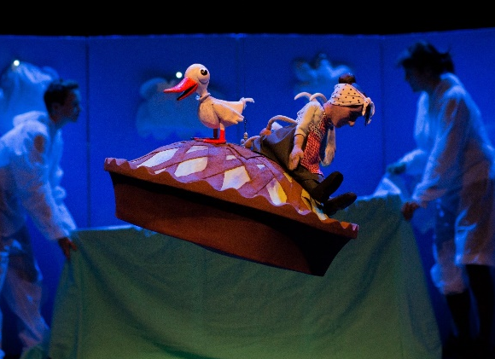
Rigging points:
- There are two rigging points for suspension of the puppets… both are very light and can be attached to lighting bars/grids or other fixing points
- Point one: Is positioned about 1.5 m in front of the set and is off centre towards SL. This is a fixed hanging line. (see: right top picture)
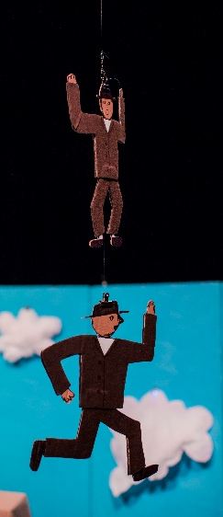
- Point two: Is positioned above the set off centre towards SR. it is a pulley line, with two cardboard figures raised up on it. (see: right bottom picture)
- The lines and fixings are provided by the company
- The company manager Jacky Crosher has many years’ experience of aerial rigging for circus and has a rigging qualification.
- Access to the ceiling or lighting points required on fit –up day.
- Access provided by venue from ladder, tallascope or other suitable equipment
- Please contact if more information required

